Pranav Krishnan

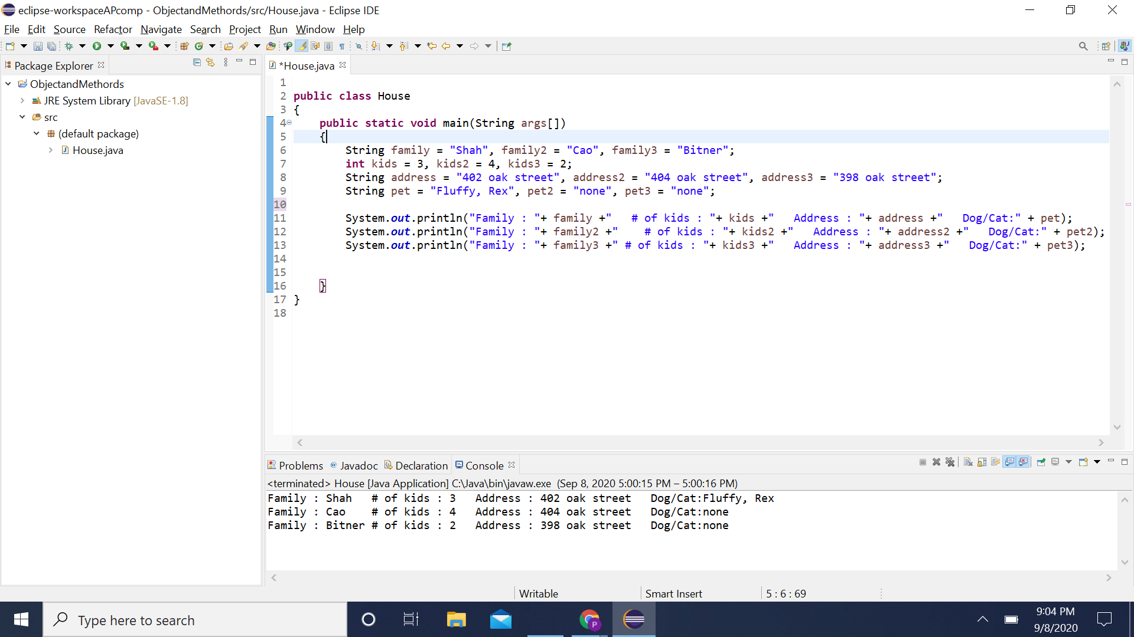

public class House

{

public static void main(String args[])

{

String family = "Shah", family2 = "Cao", family3 = "Bitner";

int kids = 3, kids2 = 4, kids3 = 2;

String address = "402 oak street", address2 = "404 oak street", address3 = "398 oak street";

String pet = "Fluffy, Rex", pet2 = "none", pet3 = "none";

System.out.println("Family : "+ family +" # of kids : "+ kids +" Address : "+ address +" Dog/Cat:" + pet);

System.out.println("Family : "+ family2 +" # of kids : "+ kids2 +" Address : "+ address2 +" Dog/Cat:" + pet2);

System.out.println("Family : "+ family3 +" # of kids : "+ kids3 +" Address : "+ address3 +" Dog/Cat:" + pet3);

}

}